A000-AM,S-Peru-Moche-Shaman Mask-Copper-100-700 CE

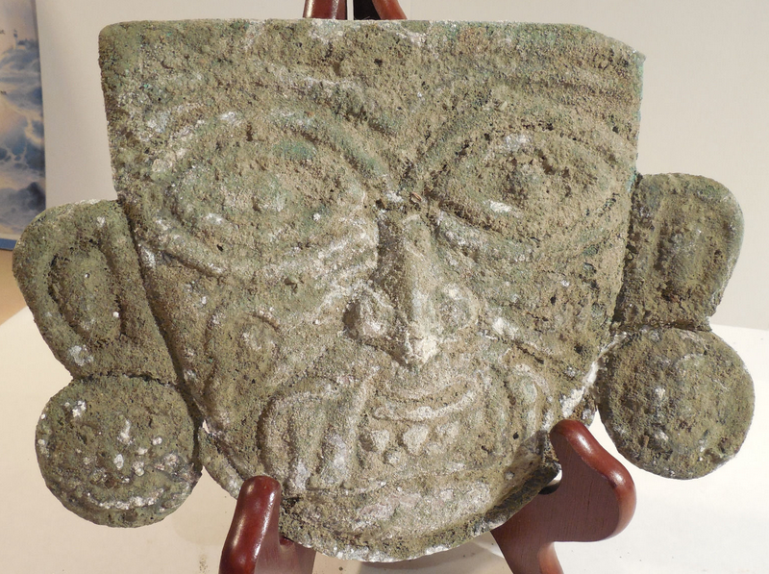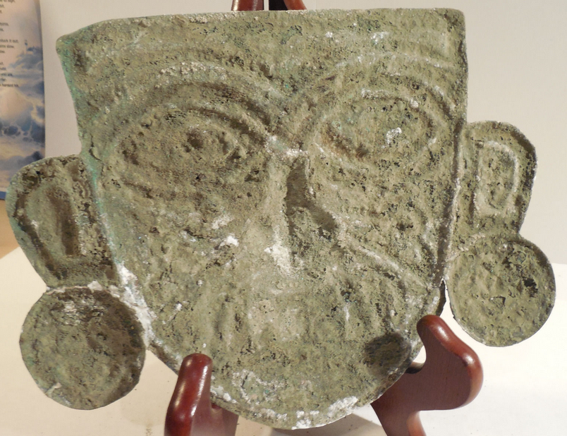

**Case No.: 7**

**Accession No.**

**Formal Label:**

**Display Description:**

This Moche Copper Shaman Mask was made by the Moche Culture copper smiths of Coastal Peru. This copper mask is in the form of a Shaman or Warrior. He has fangs coming from his mouth suggestive of a feline predator and facial tattoos and scarification. He has large ear spools, the bottom of the right one was repaired. This ancient artifact has heavy oxidation and dents.

The **Moche (**Mochica**) civilization** flourished in northern Peru with its capital near present-day Moche, Trujillo, Peru from about 100 to 700 CE during the [Regional Development Epoch](https://en.wikipedia.org/wiki/Cultural_periods_of_Peru). While this issue is the subject of some debate, many scholars contend that the Moche were not politically organized as a monolithic empire or state. Rather, they were likely a group of autonomous polities that shared a common elite culture, as seen in the rich [iconography](https://en.wikipedia.org/wiki/Iconography) and [monumental](https://en.wikipedia.org/wiki/Monument) architecture that survives today.

**LC Classification:**

**Date or Time Horizon:**

**Geographical Area:**

**Map:**

**GPS coordinates:**

**Cultural Affiliation:**

**Media:**

**Dimensions:**

**Weight:**

**Condition:**

**Provenance:**

**Discussion:**

**References:**

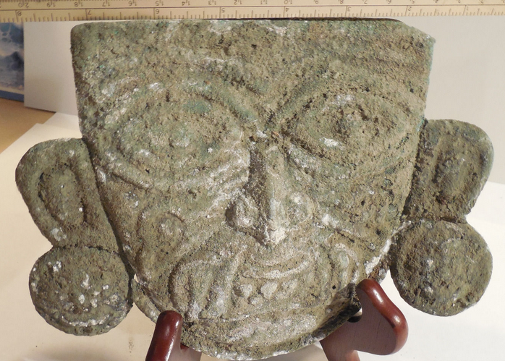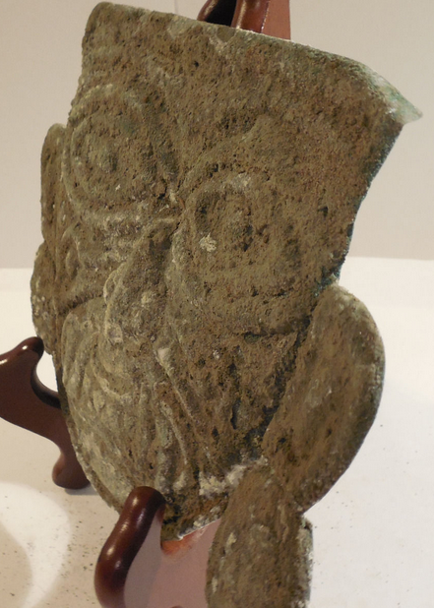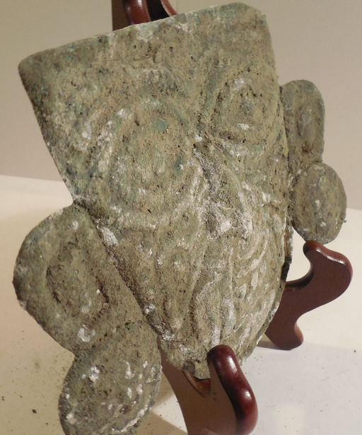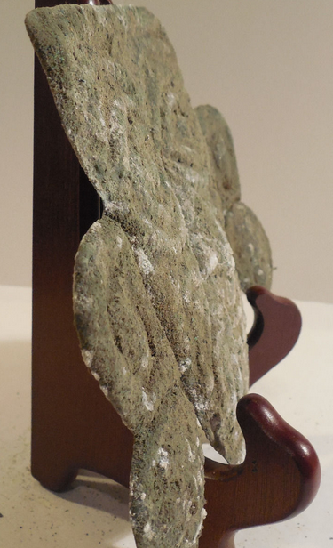

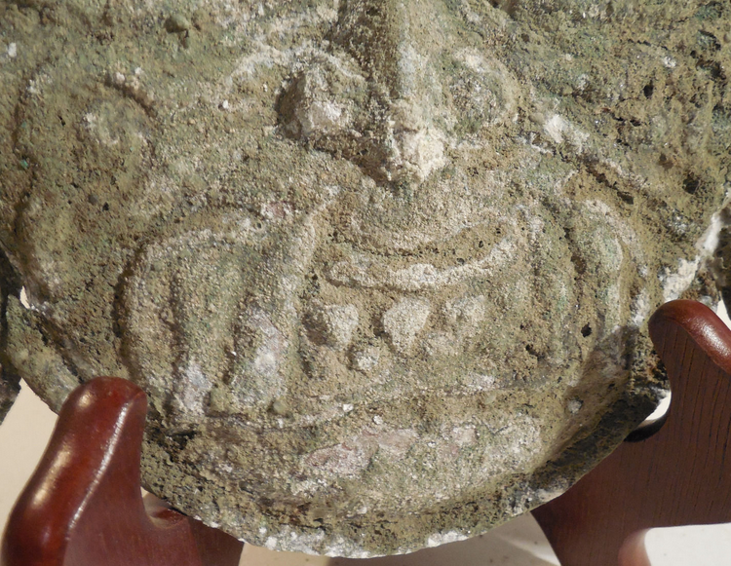

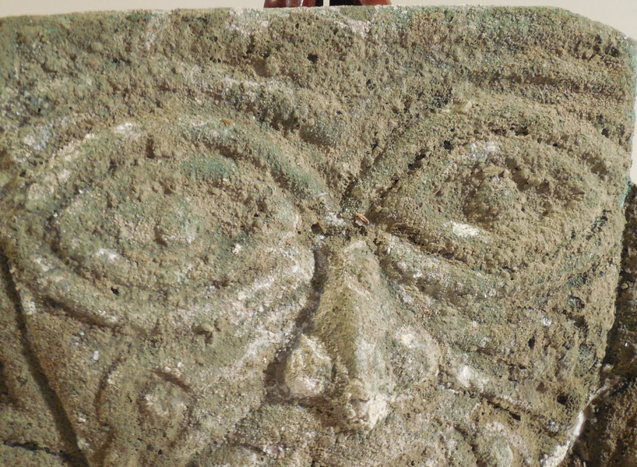

**Order details**

**Sales order**

Sold by [**ancientgas**](http://myworld.ebay.com/ancientgas) ( [992](http://feedback.ebay.com/ws/eBayISAPI.dll?ViewFeedback&userid=ancientgas" \o "opens in new window or tab" \t "_blank) )

**Delivery package 1 of 1**

Estimated delivery **Wednesday, Dec 30, 2015** **- Monday, Jan 4, 2016**

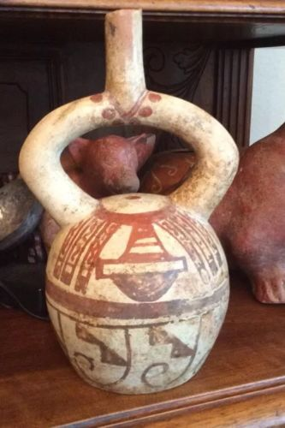

[**Moche IV Blow Bottle 400-600AD Weapon Bundle And Wave + Step Motif**](http://www.ebay.com/itm/221952944734)

|  |  |
| --- | --- |
| Item price | $400.00 |
| Quantity | 1 |
| Item number | 221952944734 |
| Shipping service | USPS Priority Mail Large Flat Rate Box |

**Sales order**

Sold by [**bobski117**](http://myworld.ebay.com/bobski117) ( [2807](http://feedback.ebay.com/ws/eBayISAPI.dll?ViewFeedback&userid=bobski117) )

**Delivery package 1 of 1**

Estimated delivery **Tuesday, Dec 29, 2015** **- Saturday, Jan 2, 2016**

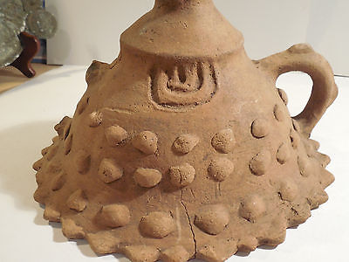

[**Colima Large Incense Lid Shaft Tomb Pre-Columbian Archaic Ancient Artifact Mayan**](http://www.ebay.com/itm/191762068598)

|  |  |
| --- | --- |
| Item price | $34.01 |
| Quantity | 1 |
| Item number | 191762068598 |
| Shipping service | USPS Priority Mail |

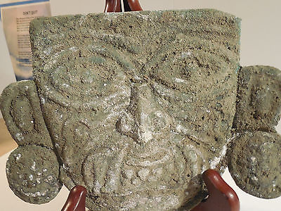

[**Moche Copper Shaman Mask Pre-Columbian Archaic Ancient Artifact Chimu Inca Mayan**](http://www.ebay.com/itm/121843120911)

|  |  |
| --- | --- |
| Item price | $520.00 |
| Quantity | 1 |
| Item number | 121843120911 |
| Shipping service | USPS Priority Mail |